|  |  |
| --- | --- |
| **MRU** | **Department of Computer Science & Technology, MRU, Faridabad** |
| **Lab Assignment 1:** Java BasicProgramming |
| **Subject:** Advance Java Workshop **Subject Code**: **CSW308B** **Semester: V** | |
|  | |

**Objectives**

* **To identify the data types required.**
* **To use the loops and conditional statement.**
* **To use arrays**
* **To implement inheritance in java.**
* **To define and use interfaces.**
* **Demonstrate exception handling mechanism in java**

**CO1**

1. Write a program that prompts the user to input days, hours, minutes, and seconds it

took a mail to reach a destination. The output is total time in seconds for the mail to

reach its destination.

**CODE:**

import java.util.*;

import java.io.*;

public class Lab1_1 {

public static void main(String[] args) {

Scanner sc= new Scanner(System.in);

System.out.println("Enter no of days:");

int days=sc.nextInt();

System.out.println("Enter no of hours:");

int hours=sc.nextInt();

System.out.println("Enter no of minutes:");

int minutes=sc.nextInt();

System.out.println("Enter no of seconds:");

int seconds=sc.nextInt();

int total_seconds=(days*24*60*60)+(hours*60*60)+(minutes*60)+seconds;

System.out.println("Total seconds="+total_seconds);

}

}

**OUTPUT:**

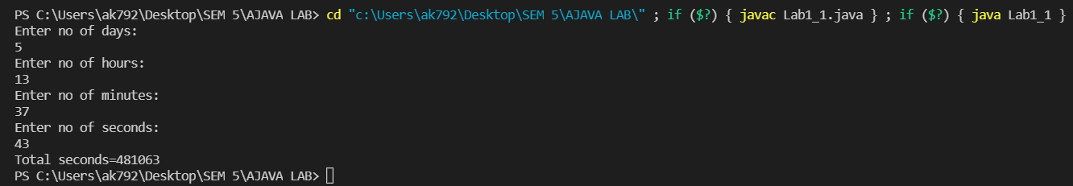

1. According to the grading policy, final grade is determined by the average of four test

scores. Create a program to read student’s first name, last name, and four test scores.

The program outputs the student’s last name, four test scores, and the average of test scores of four different students. Find the best student also and display the details of best student.

1. Create an application that calculates your daily driving cost, so that you can estimate how much money could be saved by car pooling, which also has other advantages such as reducing carbon emissions and reducing traffic congestion. The application should input the following information and display the user’s cost per day of driving to work:

Total miles driven per day

Cost per gallons of gasoline

Average miles per gallon

Parking fees per day

Tolls per day

1. Write a program to generate Fibonacci series upto the limit entered by the user

**CODE:**

import java.util.*;

public class Lab1_4 {

public static void main(String args[]){

int i,c=0,n;

Scanner sc = new Scanner(System.in);

System.out.println("Enter a number to generate fibonacci series");

n=sc.nextInt();

int a=0;

int b=1;

while(c<=n){

System.out.print(c+" ");

a=b;

b=c;

c=a+b;

}

}

}

**OUTPUT:**



1. Given the monthly salary of an employee, compute the bonus. The bonus is $1000

plus 2% of the amount above $7000 of the employee’s annual salary. Assume that

every employee has annual salary above $7000.

1. Write a java program to create n objects of the Student class. Assign roll numbers in the ascending order. Accept name and percentage from the user for each object. Display details of all the students.
2. Define a class Employee having private members - id, name, department, salary. Define default and parameterized constructors. Create a subclass called "Manager" with private member bonus. Define methods accept and display in both the classes. Create n objects of the Manager class and display the details of the manager having the maximum total salary (salary+bonus)
3. Define an interface "IntOperations" with methods to check whether an integer ispositive, negative, even, odd, prime and operations like factorial and sum of digits. Define a class MyNumber having one private int data member. Write a default constructor to initialize it to 0 and another constructor to initialize it to a value (Use this). Implement the above interface. Create an object in main. Use command line arguments to pass a value to the object and perform the above operations using a menu.
4. Define an interface "StackOperations" which declares methods for a static stack. Define a class "MyStack" which contains an array and top as data members and implements the above interface. Initialize the stack using a constructor. Write a menu driven program to perform operations on a stack object.
5. Write a program which accept two integers and an arithmetic operator from the command line and performs the operation. Fire the following user defined exceptions:

i. If the no of arguments are less than 3 then fire "IllegalNumberOfArguments"

ii. If the operator is not an Arithmetic operator, throw "InvalidOperatorException".

iii. If result is -ve, then throw "NegativeResultException"